Instructions:
- Answer all questions using MySQL.
- Use appropriate subqueries, joins, and aggregate functions wherever applicable.
- Make sure to use proper aliasing, GROUP BY, HAVING, DISTINCT, etc., as needed.
- Data
-- Customers Table
CREATE TABLE Customers (
CustomerID INT PRIMARY KEY,
Name VARCHAR(100),
City VARCHAR(100)
);

-- Orders Table
CREATE TABLE Orders (
OrderID INT PRIMARY KEY,
CustomerID INT,
OrderDate DATE,
Amount DECIMAL(10,2),
FOREIGN KEY (CustomerID) REFERENCES Customers(CustomerID)
);

-- Products Table
CREATE TABLE Products (
ProductID INT PRIMARY KEY,
ProductName VARCHAR(100),
Price DECIMAL(10,2)
);
-- OrderDetails Table
CREATE TABLE OrderDetails (
OrderDetailID INT PRIMARY KEY,
OrderID INT,
ProductID INT,
Quantity INT,
FOREIGN KEY (OrderID) REFERENCES Orders(OrderID),
FOREIGN KEY (ProductID) REFERENCES Products(ProductID)
);

Part A – Subqueries (20 marks)
- Write a query to find customers who have placed orders in every month of the current year.
- Retrieve the names of products that have been ordered more than the average quantity across all products.
- Find customers who have never ordered a product priced above ₹1000.
- List the top 3 products by total revenue using a subquery.
- Find orders that contain only one product using a correlated subquery.

Part B – Correlated & Nested Subqueries (25 marks)
- Retrieve the names of customers who placed an order on the same date as 'John'.
- Find the name of the customer who placed the most recent order.
- Write a query to find the product that has the second lowest price using a subquery.
- Display customer names who have spent more than double the average spending.
- List customers whose total order amount is more than the total order amount of any customer from 'Delhi'.

Part C – Join + Subquery Mix (30 marks)
- Use a correlated subquery to find customers who have placed more orders than the average number of orders placed by all customers.
- Find all products whose total sales quantity is higher than the average total quantity sold per product.
- Get customers who have ordered at least one product that no one else has ordered.
- Retrieve all orders where the total order amount is equal to the maximum order amount for that customer.
- Write a query to list customers who have never placed an order with a quantity greater than 5.

Part D – Joins & Set Operations (25 marks)
- Use a subquery to list the top 5 customers by total spending.
- Find all customers who have only ordered one unique product using subqueries.
- List all orders where the amount is not in the top 10 highest order amounts.
- Retrieve customer names who placed an order in the last 7 days but not in the previous 30 days before that.
- Write a query to list all products ordered in the highest number of distinct orders.

ANSWERS
Part A – Subqueries (20 marks)
- Write a query to find customers who have placed orders in every month of the current year.
SELECT Name
FROM Customers c
WHERE NOT EXISTS (
SELECT m
FROM (
SELECT DISTINCT MONTH(OrderDate) AS m
FROM Orders
WHERE YEAR(OrderDate) = YEAR(CURDATE())
) AS months
WHERE NOT EXISTS (
SELECT 1
FROM Orders o
WHERE MONTH(o.OrderDate) = months.m
AND YEAR(o.OrderDate) = YEAR(CURDATE())
AND o.CustomerID = c.CustomerID
)
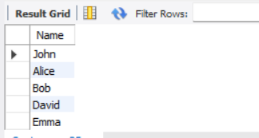
);
Output :

- Retrieve the names of products that have been ordered more than the average quantity across all products.
SELECT p.ProductName
FROM Products p
JOIN OrderDetails od ON p.ProductID = od.ProductID
GROUP BY p.ProductID
HAVING SUM(od.Quantity) > (
SELECT AVG(total_qty)
FROM (
SELECT SUM(Quantity) AS total_qty
FROM OrderDetails
GROUP BY ProductID
) AS avg_qty
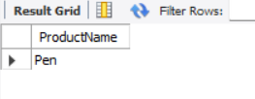
);
Output :

- Find customers who have never ordered a product priced above ₹1000.
SELECT C.Name
FROM Customers C
WHERE C.CustomerID NOT IN (
SELECT DISTINCT O.CustomerID
FROM Orders O
JOIN OrderDetails OD ON O.OrderID = OD.OrderID
JOIN Products P ON OD.ProductID = P.ProductID
WHERE P.Price > 1000
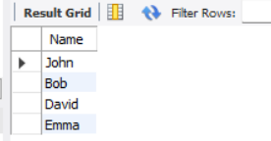
);
Output :

- List the top 3 products by total revenue using a subquery.
SELECT ProductName
FROM Products
WHERE ProductID IN (
SELECT ProductID
FROM (
SELECT OD.ProductID
FROM OrderDetails OD
JOIN Products P ON OD.ProductID = P.ProductID
GROUP BY OD.ProductID
ORDER BY SUM(OD.Quantity * P.Price) DESC
LIMIT 3
) AS TopProducts
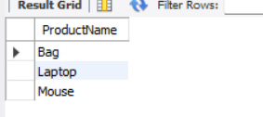
);
Output :

- Find orders that contain only one product using a correlated subquery.
SELECT O.OrderID
FROM Orders O
WHERE (
SELECT COUNT(*)
FROM OrderDetails OD
WHERE OD.OrderID = O.OrderID
) = 1;
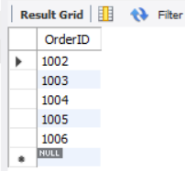
Output :

Part B – Correlated & Nested Subqueries (25 marks)
- Retrieve the names of customers who placed an order on the same date as 'John'.
SELECT DISTINCT c2.Name
FROM Orders o1
JOIN Customers c1 ON o1.CustomerID = c1.CustomerID
JOIN Orders o2 ON o1.OrderDate = o2.OrderDate
JOIN Customers c2 ON o2.CustomerID = c2.CustomerID
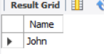
WHERE c1.Name = 'John';
Output :

- Find the name of the customer who placed the most recent order.
SELECT C.Name
FROM Customers C
JOIN Orders O ON C.CustomerID = O.CustomerID
WHERE O.OrderDate = (
SELECT MAX(OrderDate)
FROM Orders
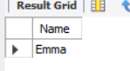
);
Output :

- Write a query to find the product that has the second lowest price using a subquery.
SELECT ProductName
FROM Products
WHERE Price = (
SELECT MIN(Price)
FROM Products
WHERE Price > (
SELECT MIN(Price)
FROM Products
)
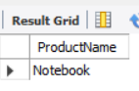
);
Output :

- Display customer names who have spent more than double the average spending.
SELECT C.Name
FROM Customers C
JOIN Orders O ON C.CustomerID = O.CustomerID
GROUP BY C.CustomerID, C.Name
HAVING SUM(O.Amount) > (
2 * (
SELECT AVG(TotalSpent)
FROM (
SELECT SUM(Amount) AS TotalSpent
FROM Orders
GROUP BY CustomerID
) AS Sub
)

);
Output :

- List customers whose total order amount is more than the total order amount of any customer from 'Delhi'.
SELECT C.Name
FROM Customers C
JOIN Orders O ON C.CustomerID = O.CustomerID
GROUP BY C.CustomerID, C.Name
HAVING SUM(O.Amount) > ALL (
SELECT SUM(O2.Amount)
FROM Customers C2
JOIN Orders O2 ON C2.CustomerID = O2.CustomerID
WHERE C2.City = 'Delhi'
GROUP BY C2.CustomerID
);
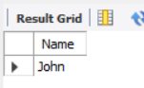
Output :

Part C – Join + Subquery Mix (30 marks)
- Use a correlated subquery to find customers who have placed more orders than the average number of orders placed by all customers.
SELECT C.Name
FROM Customers C
WHERE (
SELECT COUNT(*)
FROM Orders O
WHERE O.CustomerID = C.CustomerID
) > (
SELECT AVG(OrderCount)
FROM (
SELECT COUNT(*) AS OrderCount
FROM Orders
GROUP BY CustomerID
) AS Sub
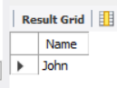
);
Output :

- Find all products whose total sales quantity is higher than the average total quantity sold per product.
SELECT p.ProductName
FROM Products p
JOIN OrderDetails od ON p.ProductID = od.ProductID
GROUP BY p.ProductID
HAVING SUM(od.Quantity) > (
SELECT AVG(TotalQuantity)
FROM (
SELECT SUM(Quantity) AS TotalQuantity
FROM OrderDetails
GROUP BY ProductID
) AS ProductTotals
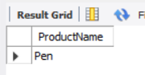
);
Output :

- Get customers who have ordered at least one product that no one else has ordered.
SELECT DISTINCT c.Name
FROM Customers c
JOIN Orders o ON c.CustomerID = o.CustomerID
JOIN OrderDetails od ON o.OrderID = od.OrderID
WHERE od.ProductID IN (
SELECT ProductID
FROM OrderDetails
GROUP BY ProductID
HAVING COUNT(DISTINCT OrderID) = 1
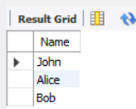
);
Output :

- Retrieve all orders where the total order amount is equal to the maximum order amount for that customer.
SELECT o.*
FROM Orders o
WHERE o.Amount = (
SELECT MAX(o2.Amount)
FROM Orders o2
WHERE o2.CustomerID = o.CustomerID
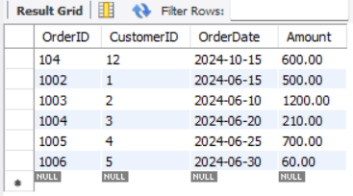
);
Output :

- Write a query to list customers who have never placed an order with a quantity greater than 5.
SELECT DISTINCT c.Name
FROM Customers c
WHERE c.CustomerID NOT IN (
SELECT o.CustomerID
FROM Orders o
JOIN OrderDetails od ON o.OrderID = od.OrderID
WHERE od.Quantity > 5
);
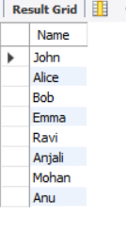
Output :

Part D – Joins & Set Operations (25 marks)
- Use a subquery to list the top 5 customers by total spending.
SELECT c.Name, SUM(o.Amount) AS TotalSpent
FROM Customers c
JOIN Orders o ON c.CustomerID = o.CustomerID
GROUP BY c.CustomerID
ORDER BY TotalSpent DESC
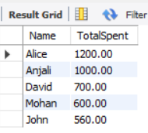
LIMIT 5;
Output :

- Find all customers who have only ordered one unique product using subqueries.
SELECT c.Name
FROM Customers c
WHERE c.CustomerID IN (
SELECT o.CustomerID
FROM Orders o
JOIN OrderDetails od ON o.OrderID = od.OrderID
GROUP BY o.CustomerID
HAVING COUNT(DISTINCT od.ProductID) = 1

);
Output :

- List all orders where the amount is not in the top 10 highest order amounts.
SELECT *
FROM Orders
WHERE Amount NOT IN (
SELECT Amount FROM (
SELECT Amount
FROM Orders
ORDER BY Amount DESC
LIMIT 10
) AS TopAmounts
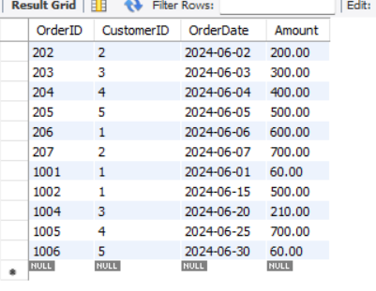
);
Output :

- Retrieve customer names who placed an order in the last 7 days but not in the previous 30 days before that.
SELECT DISTINCT c.Name
FROM Customers c
JOIN Orders o ON c.CustomerID = o.CustomerID
WHERE o.OrderDate >= CURDATE() - INTERVAL 7 DAY
AND c.CustomerID NOT IN (
SELECT o2.CustomerID
FROM Orders o2
WHERE o2.OrderDate >= CURDATE() - INTERVAL 37 DAY
AND o2.OrderDate < CURDATE() - INTERVAL 7 DAY
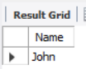
);
Output :

- Write a query to list all products ordered in the highest number of distinct orders.
SELECT ProductName
FROM Products
WHERE ProductID IN (
SELECT ProductID
FROM OrderDetails
GROUP BY ProductID
HAVING COUNT(DISTINCT OrderID) = (
SELECT MAX(OrderCount)
FROM (
SELECT COUNT(DISTINCT OrderID) AS OrderCount
FROM OrderDetails
GROUP BY ProductID
) AS ProductOrderCounts
)
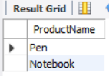
);
Output :

